Mixed-Shape Dissection

Definition
# Source: AI Source: Provided by: [Data Path: Persons Table -> ID Column: 1, Name_En Column: Motasem Essam] -> From: [ChatGPT] on [7/25/2026]
Mixed-Shape Dissection is a geometric dissection method in which a figure is divided into pieces of different geometric shapes. The pieces may include triangles, rectangles, squares, trapezoids, other polygons, circular sectors, semicircles, or regions bounded by both straight lines and curves.
The resulting pieces can be measured, compared, rearranged, or combined to form another figure or solve geometric problems involving area and shape.

Simple Definition
# Source: AI Source: Provided by: [Data Path: Persons Table -> ID Column: 1, Name_En Column: Motasem Essam] -> From: [ChatGPT] on [7/25/2026]
Mixed-shape dissection means dividing a geometric figure into pieces of different shapes, such as triangles, rectangles, and semicircles.
For example, a figure made from a rectangle and a semicircle can be separated into one rectangular piece and one semicircular piece.
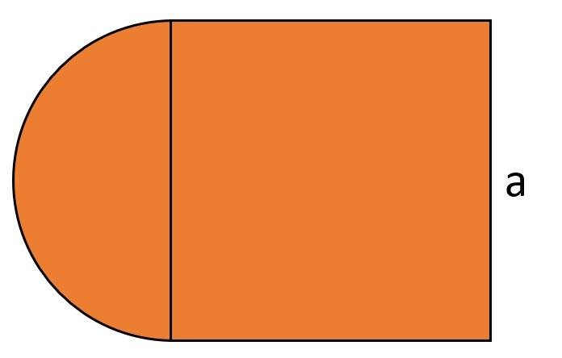

Main Classification
# Source: AI Source: Provided by: [Data Path: Persons Table -> ID Column: 1, Name_En Column: Motasem Essam] -> From: [ChatGPT] on [7/25/2026]
The following is a practical classification of mixed-shape dissection methods. These categories are descriptive, not a universally standardized taxonomy, and some can overlap.

1. Rectangular–Polygonal Dissection
# Source: AI Source: Provided by: [Data Path: Persons Table -> ID Column: 1, Name_En Column: Motasem Essam] -> From: [ChatGPT] on [7/25/2026]
Combines rectangles or squares with other polygonal pieces.
Example: An L-shaped figure divided into two rectangles.
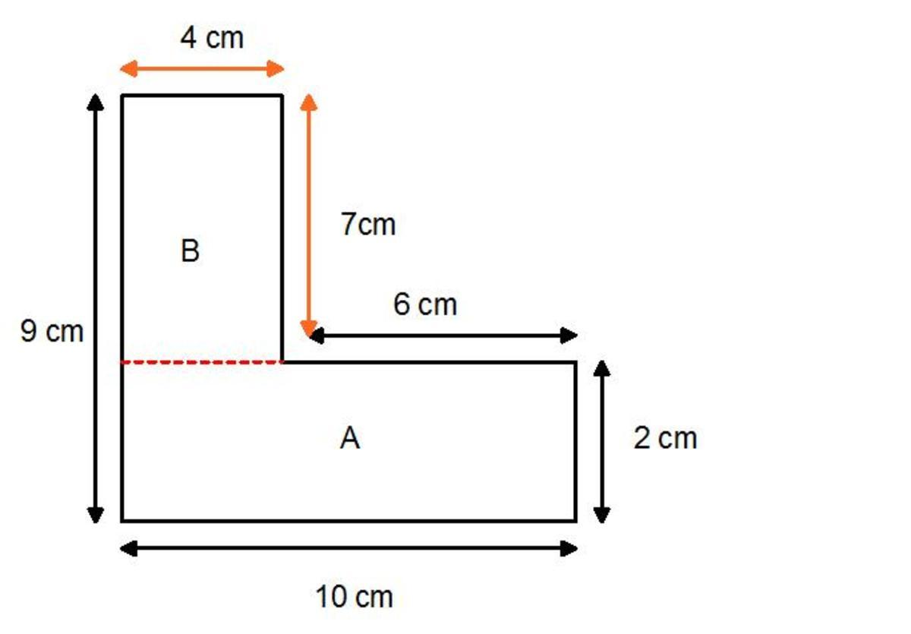
Detailed Explanation of Each Type
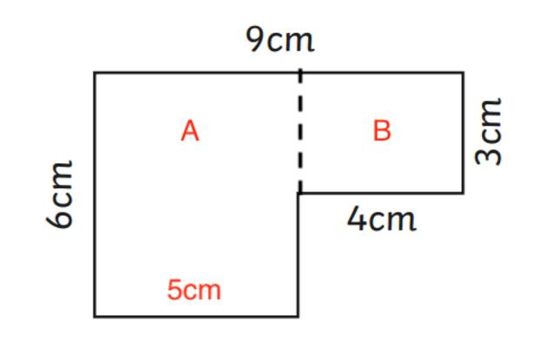
Definition: A method that divides a figure into rectangles or squares and other polygonal pieces, such as triangles or trapezoids.
Example: An L-shaped figure consists of a $6×4$ rectangle and a $3×2$ rectangle attached along an edge without overlapping interiors.
The area of the first rectangle is
$$A_{1}=6×4=24$$
The area of the second rectangle is
$$A_{2}=3×2=6$$
Therefore, the total area is
$$A=A_{1}+A_{2}=\boxed{30}$$
This approach is useful for breaking complex polygonal figures into simpler shapes whose areas are easy to calculate.

2. Circular–Polygonal Dissection
# Source: AI Source: Provided by: [Data Path: Persons Table -> ID Column: 1, Name_En Column: Motasem Essam] -> From: [ChatGPT] on [7/25/2026]
Divides a figure into polygonal pieces and pieces with circular boundaries.
Example: A rectangle with a semicircular end separated into a rectangle and a semicircle.
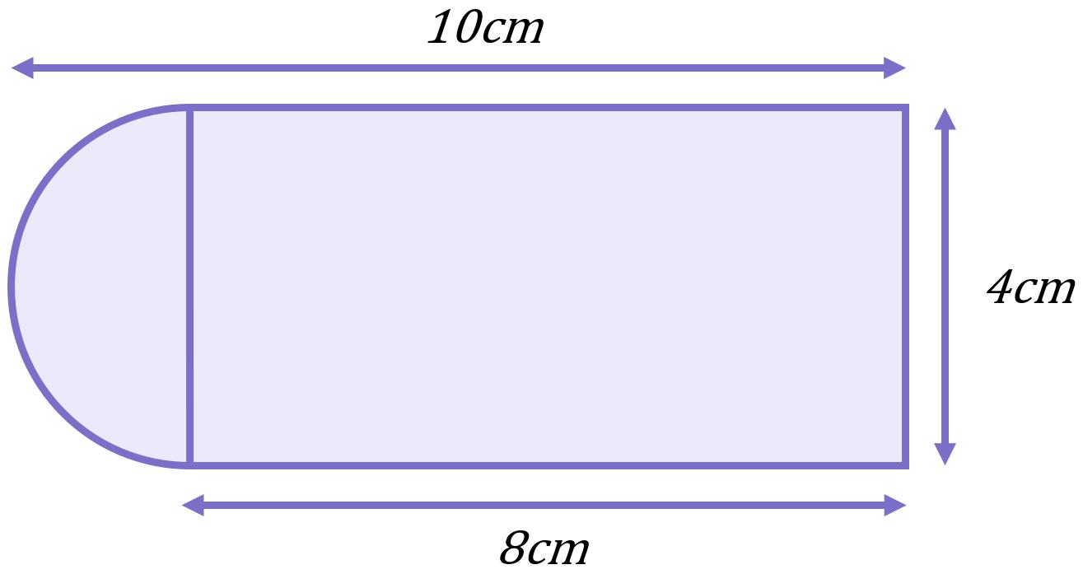
Detailed Explanation of Each Type
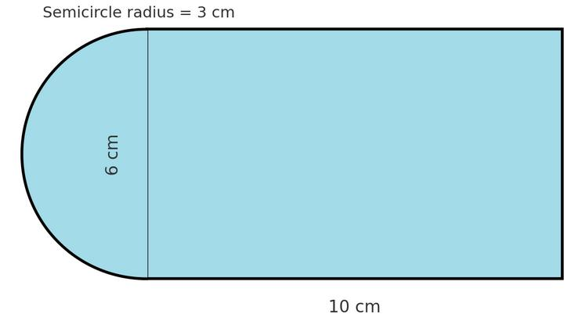
Definition: A method that divides a figure into polygonal pieces and circular pieces, such as semicircles or sectors.
Example: A rectangle measuring $8×6$ has a semicircle of radius $3$ attached along a side of length $6$.
Rectangle area:
$$A_{1}=8×6=48$$
Semicircle area:
$$A_{2}=\frac{1}{2}π{\left(3\right)}^{2}=\frac{9π}{2}$$
The total area is
$$A=48+\frac{9π}{2}$$
$$\boxed{A≈62.14}$$
The dissection makes it possible to calculate the area of each component separately before combining the results.

3. Mixed-Polygon Dissection
# Source: AI Source: Provided by: [Data Path: Persons Table -> ID Column: 1, Name_En Column: Motasem Essam] -> From: [ChatGPT] on [7/25/2026]
Uses polygonal pieces with different numbers of sides.
Example: A polygon divided into triangles, trapezoids, and other quadrilaterals.
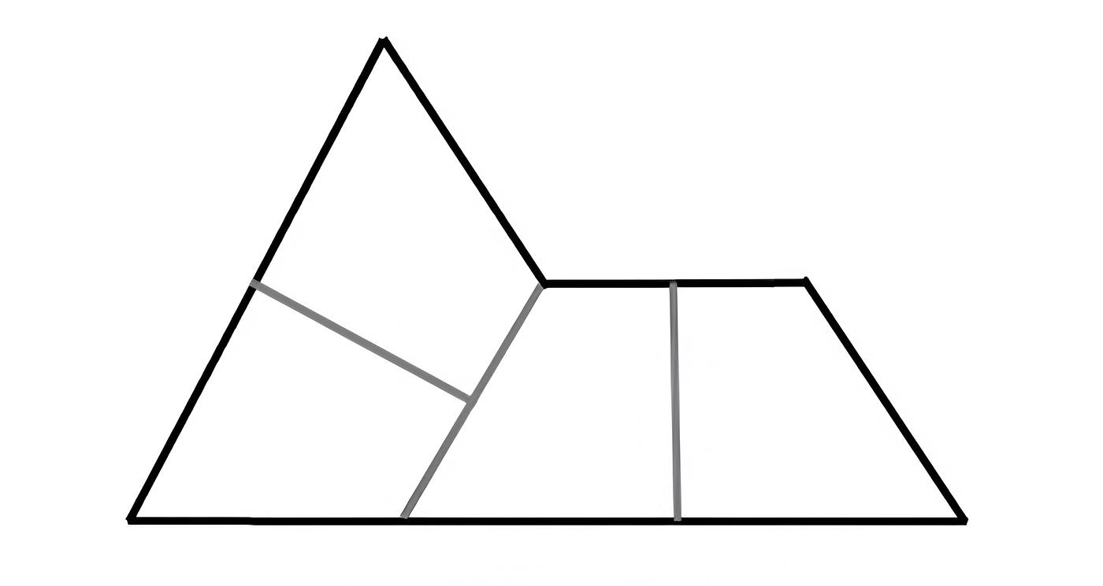
Detailed Explanation of Each Type
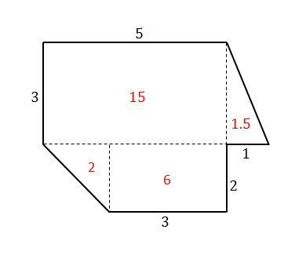
Definition: A method that divides a polygon into pieces with different numbers of sides.
Example: A polygon is divided into a triangle, a trapezoid, and a rectangle.
Suppose the triangle has base $4$ and height $3$, the trapezoid has parallel sides $4$ and $6$ with height $3$, and the rectangle measures $6×3$.
Triangle:
$$A_{1}=\frac{1}{2}\left(4\right)\left(3\right)=6$$
Trapezoid:
$$A_{2}=\frac{1}{2}\left(4+6\right)\left(3\right)=15$$
Rectangle:
$$A_{3}=6\left(3\right)=18$$
The total area is
$$A=6+15+18=\boxed{39}$$
These dimensions describe a valid partition when the pieces are positioned to fit together along matching boundaries. The area calculation assumes no gaps or overlapping interiors.

4. Multi-Component Shape Dissection
# Source: AI Source: Provided by: [Data Path: Persons Table -> ID Column: 1, Name_En Column: Motasem Essam] -> From: [ChatGPT] on [7/25/2026]
Separates a composite figure into several recognizable component shapes.
Example: A figure divided into a rectangle, a triangle, and a semicircle.
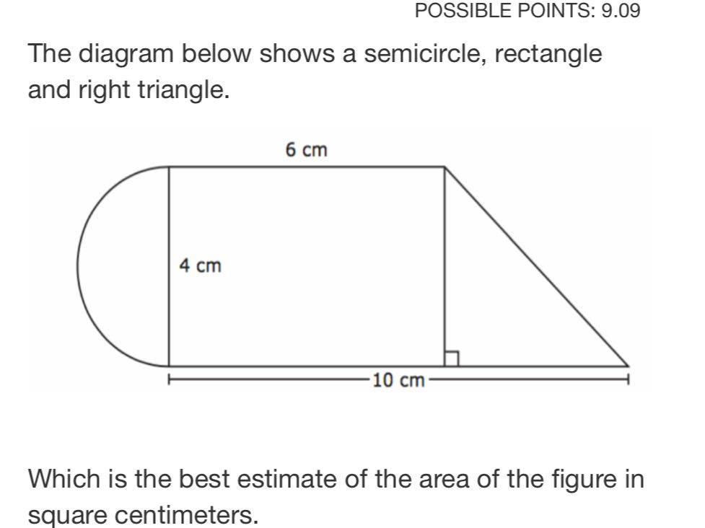
Detailed Explanation of Each Type
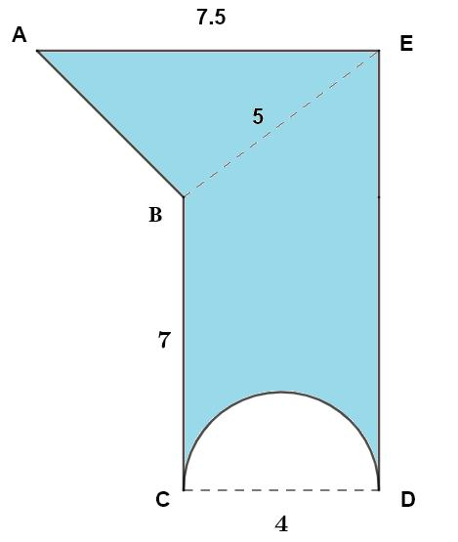
Definition: A method that separates a composite figure into several recognizable components, potentially including polygons and curved regions.
Example: A composite figure contains:
- A rectangle of dimensions $10×4$.
- A triangle with base $4$ and perpendicular height $3$.
- A semicircle with radius $2$.
Assume the pieces meet along boundaries without overlapping interiors.
Rectangle:
$$A_{1}=10\left(4\right)=40$$
Triangle:
$$A_{2}=\frac{1}{2}\left(4\right)\left(3\right)=6$$
Semicircle:
$$A_{3}=\frac{1}{2}π{\left(2\right)}^{2}=2π$$
Total area:
$$A=40+6+2π$$
$$\boxed{A=46+2π≈52.28}$$
The essential idea is to identify each component, apply the correct formula, and add the areas.

5. Irregular-Figure Mixed Dissection
# Source: AI Source: Provided by: [Data Path: Persons Table -> ID Column: 1, Name_En Column: Motasem Essam] -> From: [ChatGPT] on [7/25/2026]
Divides an irregular figure into simpler pieces of different shapes.
Example: An irregular stepped region separated into rectangles and triangles.
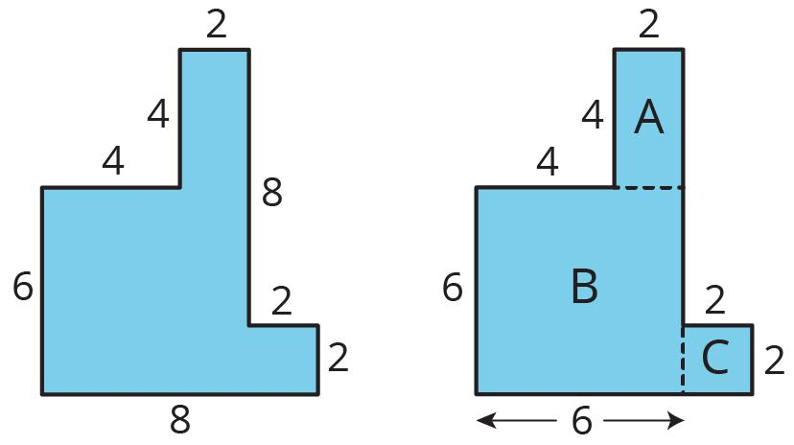
Detailed Explanation of Each Type
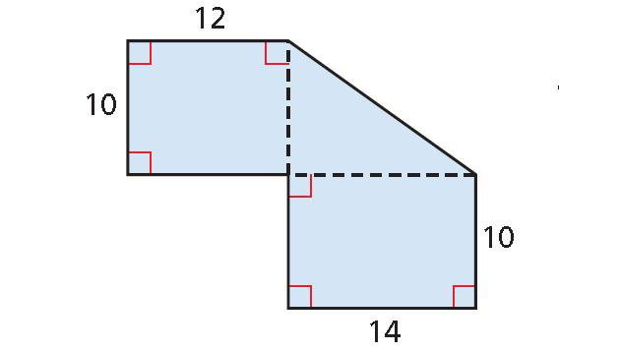
Definition: A method for simplifying an irregular figure by dividing it into standard shapes.
Example: An irregular region is composed of two non-overlapping rectangles and a right triangle.
- Rectangle 1: $6×4$.
- Rectangle 2: $3×2$.
- Right triangle: perpendicular legs $3$ and $4$.
Their areas are
$$A_{1}=24, A_{2}=6$$
$$A_{3}=\frac{1}{2}\left(3\right)\left(4\right)=6$$
Thus,
$$A=24+6+6=\boxed{36}$$
The method is especially useful for stepped shapes, floor plans, land plots, and other irregular regions that can be partitioned into familiar components.

6. Straight-Line-and-Curve Dissection
# Source: AI Source: Provided by: [Data Path: Persons Table -> ID Column: 1, Name_En Column: Motasem Essam] -> From: [ChatGPT] on [7/25/2026]
Uses both straight segments and curved boundaries to create different pieces.
Example: A figure separated by a diagonal and a circular arc.
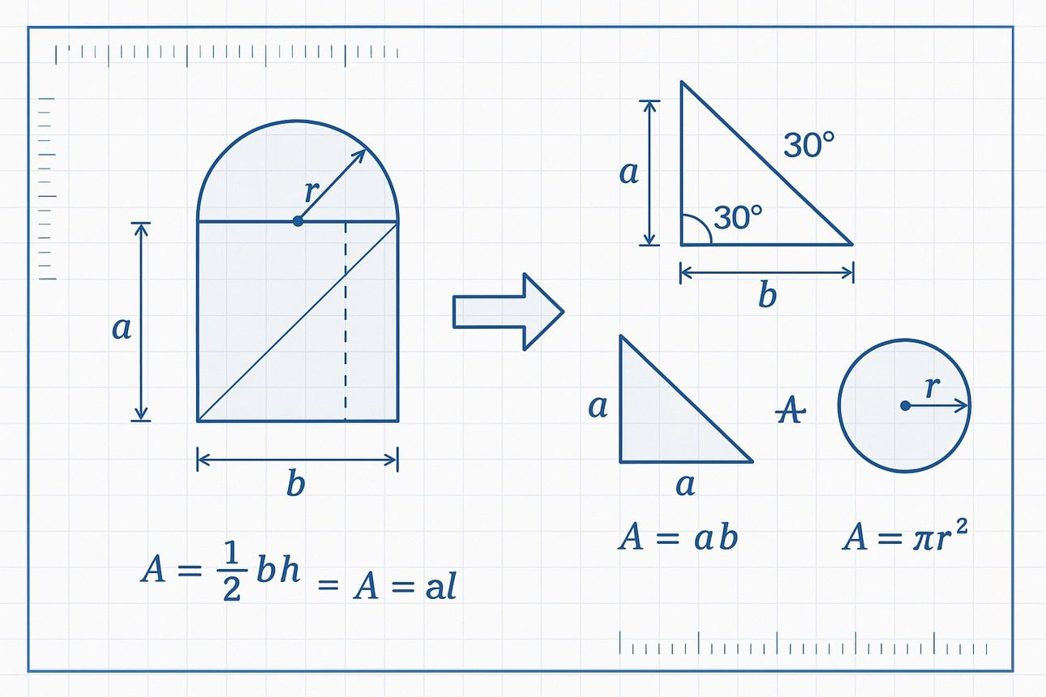
Detailed Explanation of Each Type
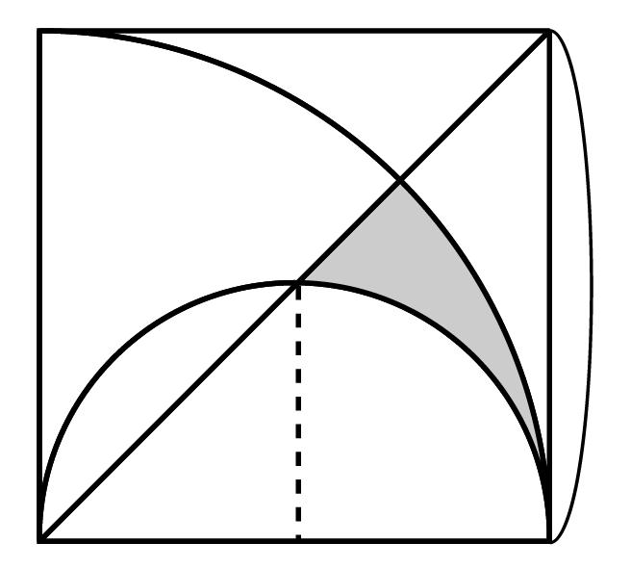
Definition: A dissection that combines straight cuts with curved boundaries, such as circular arcs.
Example: A disk of radius $5$ is divided by a chord whose perpendicular distance from the center is $3$. The chord separates the disk into a minor segment and a major segment.
The chord length is
$$c=2\sqrt{5^{2}-3^{2}}=8$$
The minor segment area can be calculated as the corresponding sector area minus the isosceles triangle area. Let
$$θ=2\cos^{-1}\left(\frac{3}{5}\right)$$
Then
$$A_{\text{minor}}={\frac{1}{2}\left(5\right)}^{2}\left(θ-\sin{θ}\right)≈11.18$$
The remaining region has area
$$A_{\text{major}}=25π-A_{\text{minor}}$$
$$\boxed{A_{\text{major}}≈67.36}$$
The two areas sum to $25π$, the area of the original disk.

7. Equal-Area Mixed-Shape Dissection
# Source: AI Source: Provided by: [Data Path: Persons Table -> ID Column: 1, Name_En Column: Motasem Essam] -> From: [ChatGPT] on [7/25/2026]
Divides a figure into different-shaped pieces with equal areas.
Example: A region divided into a triangle and a rectangle that have the same area.
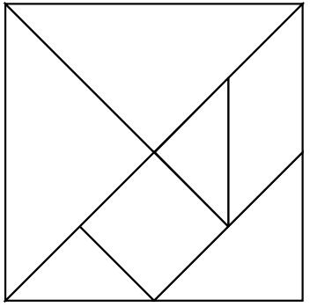
Detailed Explanation of Each Type
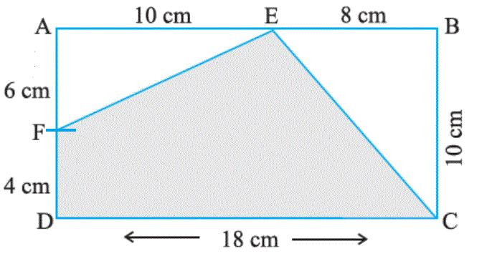
Definition: A method that creates pieces of different shapes but equal areas.
Example: A rectangle measuring $4×3$ is compared with a triangle whose base is $4$ and height is $6$.
Rectangle area:
$$A_{1}=4\left(3\right)=12$$
Triangle area:
$$A_{2}=\frac{1}{2}\left(4\right)\left(6\right)=12$$
Therefore,
$$\boxed{A_{1}=A_{2}=12}$$
This example demonstrates equal area between different shapes. It does not by itself show that the rectangle can be cut and rearranged into that particular triangle; an actual dissection requires cuts and piece placements that geometrically fit.

8. Rearrangement-Based Mixed-Shape Dissection
# Source: AI Source: Provided by: [Data Path: Persons Table -> ID Column: 1, Name_En Column: Motasem Essam] -> From: [ChatGPT] on [7/25/2026]
Uses pieces of different shapes that are rearranged to form a new figure.
Example: Triangular and trapezoidal pieces arranged into a rectangle.
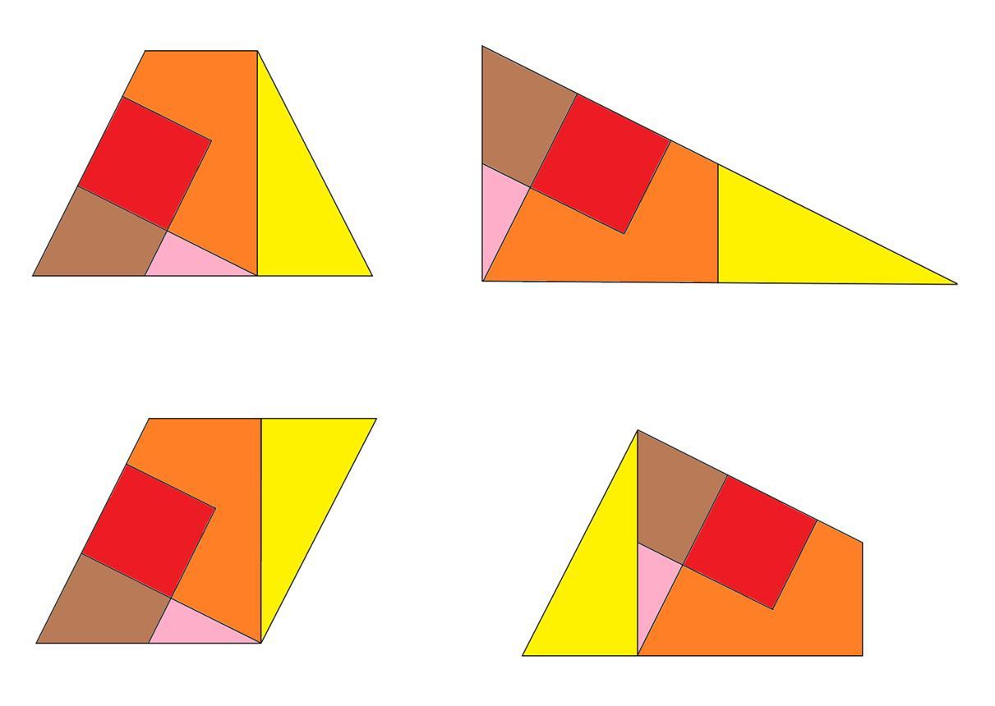
Detailed Explanation of Each Type
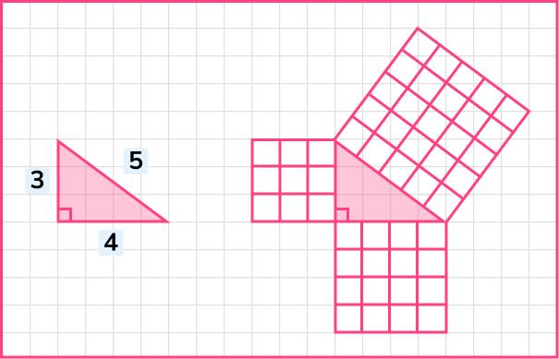
Definition: A method that cuts a figure into different-shaped pieces and rearranges them to form a new figure.
Example: Two congruent right triangles, each with perpendicular legs $3$ and $4$, can be joined along their hypotenuses to form a $3×4$ rectangle.
Area of one triangle:
$$A_{1}=\frac{1}{2}\left(3\right)\left(4\right)=6$$
Area of both triangles:
$$A_{\text{total}}=2\left(6\right)=12$$
Area of the rectangle:
$$A_{\text{rectangle}}=3\left(4\right)=12$$
Thus,
$$\boxed{A_{\text{total}}=12}$$
The arrangement works because the two congruent triangles can share their equal hypotenuse edges, with their right-angle vertices at opposite sides of the resulting rectangle.

9. Grid-Assisted Mixed-Shape Dissection
# Source: AI Source: Provided by: [Data Path: Persons Table -> ID Column: 1, Name_En Column: Motasem Essam] -> From: [ChatGPT] on [7/25/2026]
Uses a grid to guide the division of a figure into different types of pieces.
Example: A grid applied to a figure with straight and curved boundaries.
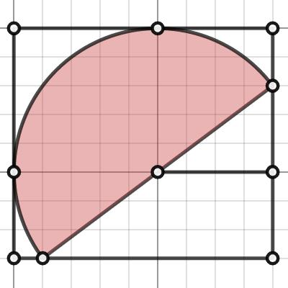
Detailed Explanation of Each Type
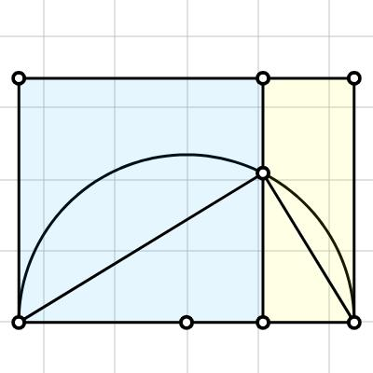
Definition: A method that uses a grid to help plan or analyze a dissection involving different kinds of pieces.
Example: A rectangle measuring $8×6$ contains a semicircular region of radius $3$ attached along its short side. A grid helps identify the rectangular component and the curved component.
Rectangle area:
$$A_{1}=8\left(6\right)=48$$
Semicircle area:
$$A_{2}=\frac{1}{2}π{\left(3\right)}^{2}=\frac{9π}{2}$$
Total area:
$$\boxed{A=48+\frac{9π}{2}}$$
The grid can assist with dimensions and alignment, but curved regions still require circular formulas or suitable approximations; a grid alone does not make every partial cell rectangular.

10. Multi-Stage Mixed-Shape Dissection
# Source: AI Source: Provided by: [Data Path: Persons Table -> ID Column: 1, Name_En Column: Motasem Essam] -> From: [ChatGPT] on [7/25/2026]
Divides a figure in successive stages, producing different kinds of pieces.
Example: A composite figure first divided into rectangles, then into triangles and curved regions.
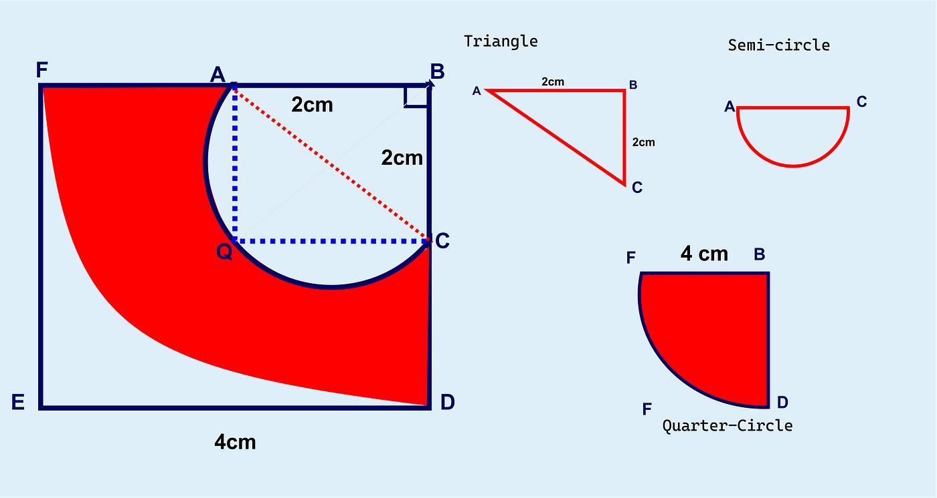
Detailed Explanation of Each Type
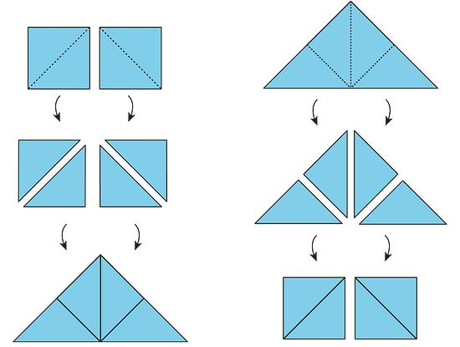
Definition: A method that subdivides a figure in successive stages, producing different types of pieces as the dissection progresses.
Example: A square of side $8$ is first divided into four $4×4$ squares. One of those smaller squares is then divided along a diagonal into two right triangles.
Original area:
$$A=8^{2}=64$$
The three unchanged squares have combined area
$$A_{1}=3\left(16\right)=48$$
The two triangles each have area
$$A_{2}=\frac{1}{2}\left(4\right)\left(4\right)=8$$
Together, the two triangles have area $16$. Therefore,
$$A_{\text{total}}=48+8+8=\boxed{64}$$
The final pieces consist of three squares and two triangles, and their total area equals the original square's area.

Key Formulas for Mixed-Shape Dissection
# Source: AI Source: Provided by: [Data Path: Persons Table -> ID Column: 1, Name_En Column: Motasem Essam] -> From: [ChatGPT] on [7/25/2026]
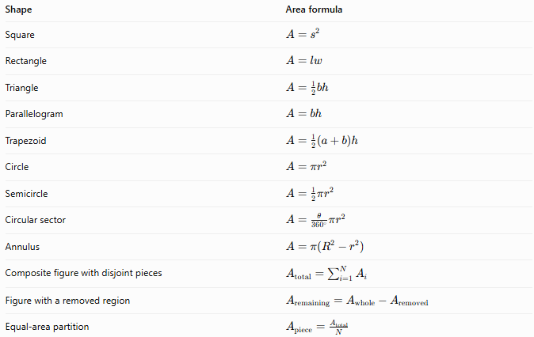
Shape | Area formula
Square | $$A=s^{2}$$
Rectangle | $$A=lw$$
Triangle | $$A=\frac{1}{2}bh$$
Parallelogram | $$A=bh$$
Trapezoid | $$A=\frac{1}{2}\left(a+b\right)h$$
Circle | $$A=πr^{2}$$
Semicircle | $$A=\frac{1}{2}πr^{2}$$
Circular sector | $$A=\frac{θ}{{360}^{∘}}πr^{2}$$
Annulus | $$A=π\left(R^{2}-r^{2}\right)$$
Composite figure with disjoint pieces | $$A_{\text{total}}=\sum_{i=1}^{N}{A_{i}}$$
Figure with a removed region | $$A_{\text{remaining}}=A_{\text{whole}}-A_{\text{removed}}$$
Equal-area partition | $$A_{\text{piece}}=\frac{A_{\text{total}}}{N}$$
For overlapping regions, avoid double counting. For two regions $A$ and $B$,
$$\operatorname{Area}\left(A∪B\right)=\operatorname{Area}\left(A\right)+\operatorname{Area}\left(B\right)-\operatorname{Area}\left(A∩B\right)$$
Important: When using the sum-of-areas formula, the pieces must cover the intended figure without gaps or overlapping interiors.

Comparison with Other Dissection Methods
# Source: AI Source: Provided by: [Data Path: Persons Table -> ID Column: 1, Name_En Column: Motasem Essam] -> From: [ChatGPT] on [7/25/2026]
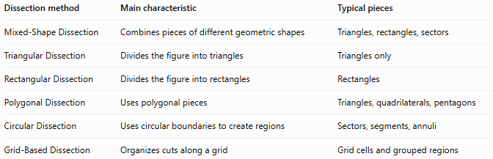
Dissection method | Main characteristic | Typical pieces
Mixed-Shape Dissection | Combines pieces of different geometric shapes | Triangles, rectangles, sectors
Triangular Dissection | Divides the figure into triangles | Triangles only
Rectangular Dissection | Divides the figure into rectangles | Rectangles
Polygonal Dissection | Uses polygonal pieces | Triangles, quadrilaterals, pentagons
Circular Dissection | Uses circular boundaries to create regions | Sectors, segments, annuli
Grid-Based Dissection | Organizes cuts along a grid | Grid cells and grouped regions
These methods can overlap. For example, a figure divided into rectangles and triangles using grid-aligned cuts is simultaneously a mixed-shape dissection and a grid-assisted dissection.

Classification Summary
# Source: AI Source: Provided by: [Data Path: Persons Table -> ID Column: 1, Name_En Column: Motasem Essam] -> From: [ChatGPT] on [7/25/2026]
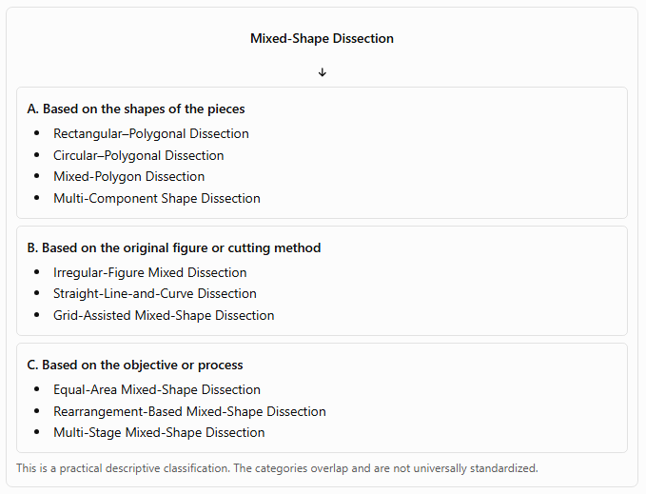
Mixed-Shape Dissection
A. Based on the shapes of the pieces
- Rectangular–Polygonal Dissection
- Circular–Polygonal Dissection
- Mixed-Polygon Dissection
- Multi-Component Shape Dissection
B. Based on the original figure or cutting method
- Irregular-Figure Mixed Dissection
- Straight-Line-and-Curve Dissection
- Grid-Assisted Mixed-Shape Dissection
C. Based on the objective or process
- Equal-Area Mixed-Shape Dissection
- Rearrangement-Based Mixed-Shape Dissection
- Multi-Stage Mixed-Shape Dissection
This is a practical descriptive classification. The categories overlap and are not universally standardized.

Key Points
# Source: AI Source: Provided by: [Data Path: Persons Table -> ID Column: 1, Name_En Column: Motasem Essam] -> From: [ChatGPT] on [7/25/2026]
- Mixed-shape dissection produces pieces belonging to different geometric shape families.
- The pieces may have straight boundaries, curved boundaries, or both.
- Area calculations usually involve applying different formulas to individual pieces.
- Rearrangement-based dissection must preserve the pieces' dimensions and shapes, apart from rigid repositioning or turning them over.
- Equal-area pieces do not have to be congruent.
- Multi-stage dissection changes the subdivision without changing the original figure's total area.
- A valid dissection covers the intended figure completely without gaps or overlapping interiors.

Conclusion
# Source: AI Source: Provided by: [Data Path: Persons Table -> ID Column: 1, Name_En Column: Motasem Essam] -> From: [ChatGPT] on [7/25/2026]
Mixed-Shape Dissection is a versatile geometric method for dividing a figure into pieces of different shapes, including polygons and curved regions. It is useful for analyzing irregular figures, calculating composite areas, proving area relationships, and solving geometric rearrangement problems.
The main principle is that the pieces collectively reconstruct the original figure. When the pieces form a non-overlapping partition, their individual areas add up to the original figure's area.

